Title Page

When Pigs Fly

It’s not just a figure of speech!

Brohen Verhoeven

01/19/2023

Copyright Information

Version 0.1(draft) October 10, 2005

By Mark Baldwin

Baldwin Consulting

http://baldwinconsulting.org

The Game Design Document (GDD) it the blueprint from which a computer or video game is to be built. As such, every single detail necessary to build the game must be addressed in the document (or support documents). If it’s not in the document, then it probably won’t be in the game.

Below you will find an outline for a generic Game Design Document. The problem is that no generic GDD will be able to address all the various genres for which a game may be created. For example, consider the games PacMan, SimCity and Doom. All three games required detailed design documents, but if you think about it, those documents would be entirely different! As such, when using the outline below you will find sections that will be totally meaningless to your game. But also, there will be sections that your GDD requires to describe the game. Just because it’s not in my outline, it doesn’t mean that it doesn’t belong.

The GDD is a reference document. Members of the development team will constantly be using the document to find specific information for their specific needs. Consider the size such a document may grow to in order to document every piece of the game. We don’t want the GDD to cause information overload and then become a prop under somebody’s wobbly desk. As such it is important that you organize and format the document to make it easy to use. Also note that some of these sections might not appear in the GDD itself but instead would appear in supplemental documents such as an Art Bible or Test Plan. This helps make the overall document more manageable and readable.

One last comment, a game design document is meant to be a living document. Just as when the artist changes the design of his painting every time he takes his brush to the canvas, a computer or video game evolves as code and art are created. The GDD then is the communication tool from which all the members of the team can follow that evolution.

**Document Revision history:**

|  |  |  |  |
| --- | --- | --- | --- |
| Version | Date | Author(s) | Changes |
| 0.2 | January 16, 2013 | Emile Cormier |  |
| 0.3 | January 05, 2016 | David Burchill |  |
| 0.4 | January 19, 2023 | Brohen Verhoeven | Draft of Game Design Document |
| 0.5 | April 11, 2023 | Brohen Verhoeven | Final Draft of GDD |
|  |  |  |  |
|  |  |  |  |
|  |  |  |  |

*(Use word’s “update table of contents” to generate / regenerate a table of contents. )*

Table of Contents

2. Section I - Game Overview 6

2.1. Game Concept 6

2.2. Design History 6

2.3. Feature Set 6

2.4. Genre 6

2.5. Target Audience 6

2.6. Game Flow Summary 6

2.7. Look and Feel 6

2.8. Project Scope 6

2.8.1. Number of locations 6

2.8.2. Number of levels 6

2.8.3. Number of NPC’s 6

2.8.4. Number of weapons 7

3. Section II - Gameplay and Mechanics 7

3.1. Gameplay 7

3.1.1. Game Progression 7

3.1.2. Mission/challenge Structure 7

3.1.3. Objectives – What are the objectives of the game? 7

3.1.4. Play Flow – How does the game flow for the game player 7

3.2. Mechanics 7

3.2.1. Physics 7

3.2.2. Movement 7

3.2.3. Objects 7

3.2.4. Combat 8

3.3. Screen Flow 8

3.3.1. Screen Flow Chart 8

3.3.2. Screen Descriptions 8

3.4. Game Options 8

3.5. Replaying and Saving 8

3.6. Cheats and Easter Eggs 8

4. Section III – Story, Setting and Character 8

4.1. Story and Narrative 8

4.1.1. Back story 9

4.1.2. Plot Elements 9

4.1.3. Game Progression 9

4.2. Game World 9

4.2.1. General look and feel of world. 9

4.2.2. Area #1 City 9

4.2.3. Area #2 Forest 9

4.2.4. Area #3 Canyon 9

4.3. Characters 10

4.3.1. Character #1 10

4.3.2. Character #2 10

5. Section IV – Levels 11

5.1. Level #1 11

5.1.1. Synopsis 11

5.1.2. Objectives 11

5.1.3. Physical Description 11

5.1.4. Map 11

5.1.5. Critical Path 11

5.1.6. Encounters 11

5.1.7. Level Walkthrough 11

6. Section V - Interface 12

6.1. Visual System 12

6.1.1. HUD - What controls 12

6.1.2. Menus 12

6.1.3. Rendering System 12

6.1.4. Camera 12

6.2. Control System 12

6.3. Audio 12

6.4. Music 12

6.5. Sound Effects 12

6.6. Help System 12

7. Section VI - Artificial Intelligence 12

7.1. Enemy AI 12

7.2. Support AI 13

7.2.1. Player and Collision Detection 13

7.2.2. Pathfinding 13

8. Section VII – Technical 13

8.1. Target Hardware and operating system 13

9. Section VIII – Game Art 13

9.1. Concept Art 13

9.2. Characters 13

9.3. Environments 14

9.4. Equipment 15

# Section I - Game Overview

## Game Concept

When Pigs Fly is an adventure in which you flap your way to freedom. Avoid the butcher by dodging his knives. When Pigs Fly's objective is to control and guide a pig with wings whose name is Oinker. You will guide Oinker to move across in a jumping/flying motion across three different locations.

## Design History

This is a living document and will change as you develop your game. This section maintains a history of any significant changes to your game.

The game has changed a lot since first concept, opting for a more horizontal one level design.  
The original game design involved a much higher detailed deliver and was needed to be shortened.

## Feature Set

The game includes one player that can fly and shoot projectiles and 1 non-player that can shoot projectiles. It will also contain a progression system where as the player progresses it will affect the world, and ending of the game.

## Genre

When Pigs Fly is a side-scrolling runner.

## Target Audience

The target audience is age 10+

## Game Flow Summary

The player moves throughout the game by flying through a city, a forest, and a canyon.

## Look and Feel

The game should look like a pixelated version of a general area of the world. There is a city, a forest, and a canyon that are all connected.

## Project Scope

The player has to avoid obstacles and NPC’s, while using their flight to get to the goal.

### Number of locations

There are 3 locations, a city, a forest, and a canyon.

### Number of levels

There is one level.

### Number of NPC’s

There is one NPC

### Number of weapons

There are two weapons, a player projectile (bacon-bomb) and a non-player projectile (knife throw)

# Section II - Gameplay and Mechanics

## Gameplay

### Game Progression

The game progresses in 3 stages, the initial starting stage that has the least amount of difficulty, a middle stage that has a moderate amount of difficulty, and a third stage that has the highest form of difficulty.

### Mission/challenge Structure

The mission of the player is to escape the NPC that is constantly chasing them. They can use their flight to guarantee their safety. The challenge comes with the NPC that is constantly chasing and attacking the player.

### Objectives – What are the objectives of the game?

The objective in When Pigs Fly is to escape the NPC and reach the end goal.

### Play Flow – How does the game flow for the game player

The game is split into three parts, but they are all connected. A city, a forest, and a canyon. Each location has different indications. (For example, the canyon would signal to the player that they are about to enter the canyon.)

## Mechanics

The mechanics behind When Pigs Fly involve physics, movement, and objects.

### Physics

Each section of the game there is gravity, and the player needs to fly for less or more of the time.

### Movement

#### General Movement

The player moves within the world by flying.

#### Other Movement

The NPC’s movement gradually get closer and closer to the player by the end of the game.

### Objects

#### Moving Objects

The moving objects in the game are static objects and a moving object being the NPC.

### Combat

The combat involves the player having to dodge and avoid a NPC that is constantly chasing them.

## Screen Flow

### Screen Flow Chart

### Screen Descriptions

What is the purpose of each screen?

#### Main Menu Screen

The purpose of this screen is to display the important information that will allow players to have a clear and clean user experience.

#### Options Screen

The purpose of this screen is to display the controls and options that will allow player to have the knowledge to successfully play the game.

#### Summary Screen

The purpose of this screen is to display the summary.

#### Controls Screen

The purpose of this screen is to display the controls.

#### Credits Screen

The purpose of this screen is to Credit the people who helped develop the game.

#### Game Screen

The purpose of this screen is to display the game and its environment, player, NPC’s, and UI.

## Game Options

The options include a display of set controls, an option to turn on or off the music and some information about the game.

## Replaying and Saving

The player will not be allowed to save during the game.

## Cheats and Easter Eggs

The only Easter Egg in the game is unused images and some memes hidden in the games files.

# Section III – Story, Setting and Character

## Story and Narrative

### Back story

Oinker is a simple pig who just wants to relax in the mud on the farm. But one day his owner decides to sell him for money and now he is going to be butchered. So Oinker decides he doesn’t want to become someone’s next meal and out of his desire to escape grows wings and escapes the butcher. Oinker needs to flee the city, escape through the forest, and jump over a canyon to gain their freedom.

### Plot Elements

Oinker grows wings due to him wishing he could escape. The butcher has motive to chase oinker as he paid money to butcher him.

### Game Progression

The game plays through three sections and each one has different amount of difficulty and on the last section if you make it to the goal you win.

## Game World

### General look and feel of world.

### Area #1 City

#### General Description

The city is full of tall buildings with clouds.

#### Physical Characteristics

The area has 3 types of buildings, 3 types of clouds, and pavement.

#### Connections to other areas

This area connects to the second area.

### Area #2 Forest

#### General Description

The forest is full of trees and dark clouds.

#### Physical Characteristics

The area has been shrunk due to dark clouds.

#### Connections to other areas

This area connects to the previous and final area.

### Area #3 Canyon

#### General Description

The canyon is vast but empty with a huge hole.

#### Physical Characteristics

The canyon is big and contains a giant hole.

#### Connections to other areas

This area connects to the previous area and is the final area.

## Characters

### Character #1

#### Back story

Oinker was a simple pig living a simple life until one day his master decided to sell him. Now faced with death Oinker grows wings and flees for their life.

#### Personality

Oinker has a scared expression and heavy.

#### Look

##### Physical characteristics

Oinker is a pixelated pink pig with wings.

##### Animations

Oinkers animations include a scared expression and joy. Also, the animations of the wings flapping.

#### Special Abilities

Oinker can fly, and shoot a bacon bomb.

#### Relevance to game story

Oinker is the only playable character.

#### Relationship to other characters

Oinker’s only relationship is with his new owner who is trying to catch and butcher him.

### Character #2

#### Back story

The Butcher is a hardworking man who is just trying to make ends meet.

#### Personality

The Butcher is a burly man in his late 30s, he has an angry expression due to his pig getting away.

#### Look

##### Physical characteristics

The Butcher is a pixelated man with a apron, hat, and giant knife.

##### Animations

The Butchers animations include an angry face. Also, the animations of the knife being thrown.

#### Relevance to game story

The Butcher is the antagonist to the playable character.

#### Relationship to other characters

The Butchers only relationship is with the pig who is trying to escape him.

# Section IV – Levels

## Level #1

### Synopsis

Three areas make up level #1 it is the only level in the game.

### Objectives

Get to the end without getting caught or dying.

### Physical Description

A large stretch of land that has three areas inside of it and each area has backgrounds, obstacles, sound, and allow the player to fully use all available space.

### Map

A three-part map, a city, a forest, and a canyon.

### Critical Path

There is only one direct path and that is forward.

### Encounters

The player will encounter static objects like clouds and ground, moving objects like the butcher and knives, and a canyon that provides a empty encounter that creates its on challenge.

### Level Walkthrough

The player starts at the left side of the map and needs to get to the other side.

# Section V - Interface

## Visual System

### HUD - What controls

The controls are displayed for the user in the controls menu

### Menus

There is one menu that displays New Game, Quit, and Settings and inside that menu is controls, summary and information about the game.

### Rendering System

The game is rendered before the game begins.

### Camera

The camera will follow a rectangular area around the player.

## Control System

The player controls the game by using WASD or arrow keys to map through the menu and game. The player will also use a fly button and bacon bomb button.

## Audio

The Audio is playing throughout the game and will change depending on the button pressed. (Flapping for wings, and an explosion for the bomb)

## Music

The Music is playing throughout the game will change depending on if the player wins or not.

## Sound Effects

The sound effects include sounds that are related to knife throwing, wings flapping, explosions.

## Help System

The game has an option in the menu where players can see the controls and information about the game in order to play the game.

# Section VI - Artificial Intelligence

## Enemy AI

The Enemy AI works on a rail system where they have a set path and will constantly be attacking the player.

## Support AI

### Player and Collision Detection

The player will have collision with the world, environment, and projectiles that are in the game. When the player collides with any of the previously stated parts, they will either be stopped or get hit and when they get hit they will die.

### Pathfinding

There are is one route the player can go and the pathfinding allows them to go in all directions.

# Section VII – Technical

## Target Hardware and operating system

X64 Visual Studio 2022 is supported on the following x64-bit operating systems:

* Windows 11 version 21h2 or higher
* Windows 10 version 1909 or higher
* Windows Servers 2022, 2019 and 2016 (Standard and Datacenter)

# Section VIII – Game Art

Only show concept art here (rough sketches)

## Concept Art

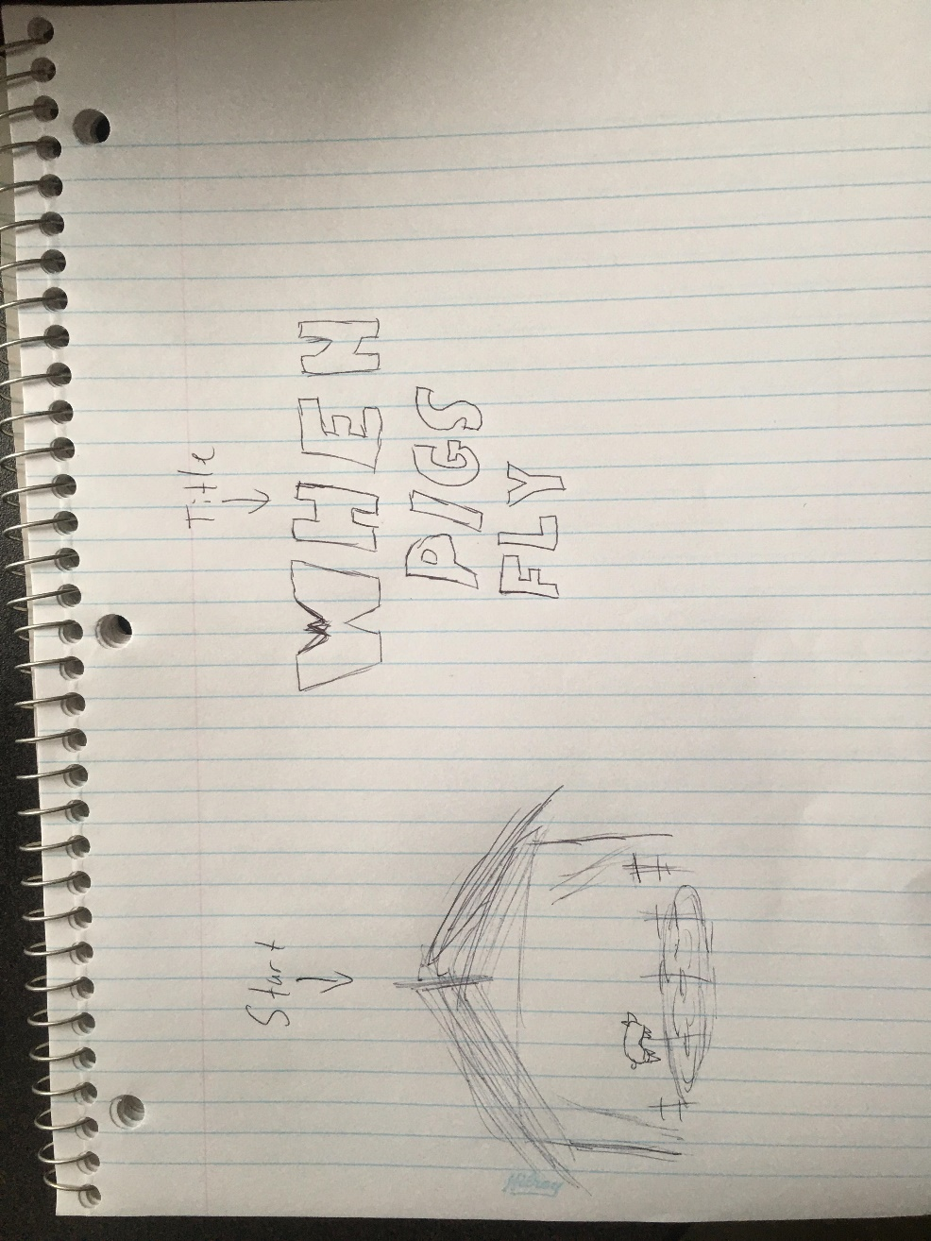

## Characters

## Environments

